ICAI AI LEVEL2
CAPSTONE PROJECT
CA. RASHMI RANJAN MISHRA, M No: 218617
AICA LEVEL 2 - B86, BHUBANESWAR
______________________________________

Title of the Project
“Capital Gain Tax Calculator (CGT Calculator): An AI-Assisted Automated System for Computation, Comparison and Presentation of Capital Gains Tax”
Capstone Project Tagline
“From Manual Capital Gain Working to Intelligent Tax Computation – An AI-Assisted CGT Calculator for Chartered Accountants.”
SL. NO. | CONTENT | PG. NO.
1 | PART - A: PLANNING STAGE
1.1 | Introduction | 2
1.2 | Problem Statement | 2
1.3 | Objectives of the Project | 3
1.4 | Scope of the Project | 3
1.5 | Proposed methodology | 4
1.6 | AI Component of the features | 6
1.7 | User Interface | 7
1.8 | Report Generation | 8
1.9 | Technology Proposed | 9
1.10 | Key Features | 10
1.11 | Expected Outcomes | 10
1.12 | Professional Relevance for Chartered Accountants | 10
1.13 | Limitations | 11
1.14 | Future Scope | 11
1.15 | Conclusion | 12
2 | PART - B: EXECUTION STAGE | 13
3 | PART - C: IMPLEMENTATION STAGE | 34

PART – A: PLANNING STAGE
1.1. Introduction
Capital gains taxation involves multiple variables such as the nature of the capital asset, date of acquisition, date of transfer, cost of acquisition, cost of improvement, transfer expenses, holding period, applicable tax rates, indexation provisions, exemptions and amendments applicable for different assessment years.
Manual computation of capital gains is therefore prone to calculation errors, omission of relevant costs, incorrect application of tax rates, and difficulty in comparing alternative methods of taxation.
The proposed Capital Gain Tax Calculator (CGT Calculator) is a desktop/web-based application designed to automate the computation and presentation of capital gains tax in a structured and user-friendly manner.
The system will particularly assist Chartered Accountants and taxpayers in determining the most beneficial tax computation, wherever the applicable provisions permit alternative methods of computation.

1.2. Problem Statement
At present, capital-gain calculations are frequently performed using spreadsheets or manually prepared working papers. Such methods may result in:
- Incorrect classification of capital assets.
- Errors in determining the period of holding.
- Incorrect calculation of indexed cost.
- Omission of direct expenses relating to transfer.
- Incorrect application of tax rates.
- Failure to compare alternative tax computation methods.
- Difficulty in identifying missing or inconsistent information.
- Repetitive manual calculations for multiple assets.
- Difficulty in presenting the computation in a professional tax-working format.
Therefore, there is a need for an automated Capital Gain Tax Calculator capable of performing calculations accurately while providing transparency and an audit trail.
1.3. Objectives of the Project
The primary objectives of the CGT Calculator are:
- To automate the computation of capital gains.
- To determine the nature and period of holding of the asset.
- To calculate - Sale consideration, Transfer expenses, Cost of acquisition, Cost of improvement, Indexed cost (wherever applicable) and Capital gain/loss etc.
- To apply the appropriate tax rate based on the relevant tax provisions.
- To provide comparative tax computation under alternative applicable methods.
- To identify the more beneficial method for the assessee, wherever legally permissible.
- To provide a clear computation sheet suitable for professional review.
- To incorporate validation checks for incomplete or inconsistent data.
- To maintain an audit trail of calculations.
- To demonstrate the practical application of AI in tax-computation workflows.

1.4. Scope of the Project
The proposed application will cover capital-gain transactions such as:
- Land & Building
- Land
- Building
- Shares (Unlisted)
- Securities (Listed)
- Other Capital Assets
The application will allow the user to enter relevant transaction details including:
Particulars | Input
Description of Asset | User Input
Date of Acquisition | User Input
Date of Transfer | User Input
Sale Consideration | User Input
Cost of Acquisition | User Input
Cost of Improvement | User Input
Date of Improvement | User Input
Transfer Expenses | User Input
Applicable Financial Year | Automated
Assessment Year | Automated
Applicable CII | System Calculation
Tax Rate | System Calculation

1.5. Proposed Methodology
The CGT Calculator will follow a structured workflow:
Input → Validation → Classification → Computation → Comparative Analysis → Tax Calculation → Exception Detection → Report Generation
Step 1 – User Input
The user enters transaction details through a simple graphical interface.
Step 2 – Data Validation
The system checks:
- Whether dates are valid.
- Whether transfer date is later than acquisition date.
- Whether mandatory fields are completed.
- Whether cost figures are reasonable.
- Whether improvement dates fall within the relevant ownership period.
- Whether the selected Assessment Year corresponds with the transaction.
Step 3 – Capital Asset Classification
The system determines the applicable category based on the information provided and the tax rules incorporated into the application.

Step 4 – Computation of Capital Gain
The application computes:
Full Value of Consideration
Less:
- Transfer expenses
- Cost of acquisition
- Cost of improvement
- Indexed costs, wherever applicable
= Taxable Capital Gain
Step 5 – Alternative Computation
Where applicable, the application will calculate capital gains using alternative permitted methods, for example:
Method A – Computation without indexation and
Method B – Computation with indexation
The application will display both results side-by-side.
Step 6 – Tax Comparison
The system will calculate the tax liability under each applicable method and identify the comparatively beneficial result.
The screen may display:
Particulars | Method A | Method B
Sale Consideration | ₹ | ₹
Less: Transfer Expenses | ₹ | ₹
Cost of Acquisition | ₹ | ₹
Cost of Improvement | ₹ | ₹
Indexed Cost | — | ₹
Capital Gain | ₹ | ₹
Applicable Tax Rate | % | %
Tax on Capital Gain | ₹ | ₹
Cess, if applicable | ₹ | ₹
Total Tax Liability | ₹ | ₹
Tax Saving | — | ₹

1.6. AI Component of the Project
To make the project appropriate for AICA Level 2, AI should not merely be used as a calculator. The system can incorporate an AI-assisted Tax Review Engine.
Proposed AI features
A. Intelligent Input Validation
AI can identify unusual or potentially incorrect entries, such as:
“The date of improvement entered is earlier than the date of acquisition. Please verify.”
B. Tax Rule Identification
Based on - Asset type, Acquisition date, Transfer date, Assessment Year, Nature of transaction etc. the system can suggest the potentially applicable computation framework.
C. Anomaly Detection
The system can flag:
- Very high improvement cost compared with acquisition cost.
- Missing transfer expenses.
- Unusual sale consideration.
- Acquisition date inconsistent with the selected tax regime.
- Missing supporting information.

D. Comparative Tax Analysis
The AI engine can explain:
“Method B results in a lower tax liability by ₹XX,XXX based on the information entered.”
E. Professional Explanation
The system can automatically generate a concise explanation of how the capital gain was calculated.

1.7. User Interface
The proposed application will have a professional Light Blue and White - CA-oriented interface consisting of: Dashboard, New Calculation, Comparison Results, CII Master, Tax Rule Master, Calculation History etc.
Transaction Input Screen
Fields for:
- Assessee details
- Asset details
- Acquisition details
- Improvement details
- Transfer details
- Expenses
Calculation Screen
A detailed computation will appear automatically.
Comparison Screen
The user will see:
“Method-wise Capital Gain & Tax Comparison”
with the lowest permissible tax liability prominently highlighted.

1.8. Report Generation
The application will generate a professional report containing:
- Assessee details
- Asset details
- Transaction details
- Cost of acquisition
- Cost of improvement
- Transfer expenses
- Applicable CII, where relevant
- Capital gain computation
- Tax computation
- Comparative analysis
- Tax-saving comparison
- AI-generated observations
- Validation warnings
- Disclaimer
- Date and time of calculation
The report may be exportable to PDF/Excel/Word.

1.9. Technology Proposed
The project is developed using:
- Python (with Antigravity Agentic AI)
- PyQt6 GUI Framework with the Light Blue & White theme for the UI
- Dual Capital Gain Engine (12.5% unindexed vs. 20% indexed with Section 112 grandfathering)
- Report Generation Engine:
- PDF Generation (reportlab)
- Excel Export (openpyxl)
- Word Memorandum Generation (python-docx)
- Data & Numeric Processing: (pandas, numpy, sqlite3)
- Complete offline capacity: No taxpayer data is ever transmitted over the network
- AI/LLM-assisted explanation and anomaly-detection layer
The architecture may be divided into:
User Interface Layer
↓
Input Validation Layer
↓
Tax Rule Engine
↓
Capital Gain Calculation Engine
↓
AI Review & Anomaly Engine
↓
Comparison Engine
↓
Report Generation Module

1.10. Key Features
The proposed CGT Calculator will provide:
- Automated capital-gain calculation
- Date-based holding-period calculation
- Cost of acquisition calculation
- Cost of improvement calculation
- Indexed-cost calculation where applicable
- Transfer-expense adjustment
- Multiple tax-method comparison
- Automatic validation
- AI-based anomaly detection
- Detailed audit trail
- PDF/Excel/Word report generation
- User-friendly CA-oriented interface

1.11. Expected Outcome
The project is expected to produce a functional Capital Gain Tax Calculator that can significantly reduce the time required for preparing capital-gain workings and minimize computational errors.
The system will provide the professional with a single-screen comparative view of capital gain and tax liability under the applicable alternative methods and assist in identifying the more beneficial legally permissible computation.

1.12. Professional Relevance for Chartered Accountants
The project has direct practical relevance to CA practice because capital-gain computation is frequently required in - Income-tax return preparation, Tax planning, Sale of immovable properties, Sale of investments, Tax audit, Assessment proceedings, Client advisory, Tax-saving analysis, Due diligence and financial planning etc.
The project demonstrates how AI can be integrated into a conventional CA workflow to improve accuracy, efficiency, consistency and professional review.

1.13. Limitations
The application will be designed as an assistive tax-computation tool and not as a substitute for professional judgment.
The final tax liability will depend upon the accuracy and completeness of information supplied by the user and the tax provisions applicable to the relevant Assessment Year.
The tax-rule database will therefore need to be periodically updated for amendments, notifications, circulars and changes in applicable provisions.

1.14. Future Scope
The application can subsequently be expanded to include:
- Integration with Income Tax return preparation.
- Automatic extraction of purchase and sale dates from documents.
- AI-based review of sale deeds.
- Multiple-property/multiple-asset computation.
- Tax-planning simulation.
- Integration with AIS/Form 26AS data.
- Automatic generation of tax-working papers.
- Cloud-based multi-user CA-office version.
- Automatic notification of changes in capital-gain provisions.

15. Conclusion
The proposed Capital Gain Tax Calculator (CGT Calculator) is an application-oriented AICA Level 2 Capstone Project that combines tax domain knowledge, automation, artificial intelligence, data validation, comparative analysis and professional reporting.
The project aims to demonstrate that AI can be effectively used by Chartered Accountants not merely for generating information but for automating repetitive tax computations, detecting anomalies, comparing legally permissible tax outcomes and assisting professional decision-making.

Important design point: Since capital-gains provisions and rates can change, the project should have a Tax Rule Master / Configuration Module rather than hard-coding rates and rules into the calculation program. This will make the project much stronger from an AICA Level 2 perspective and easier to update for future Assessment Years.

PART – B
(EXECUTION STAGE):
Steps:
- Creating a Blank Folder in the name “CGT Calculator”
- Linking the Folder in Antigravity: Clicking File – Create project
- Giving the following PROMPT for Antigravity – Capital Gain Tax Comparison Calculator
Act as a **Senior Python Developer, Chartered Accountant, Income Tax Practitioner and Tax-Audit Software Architect**.
Develop a professional **Windows desktop application** named:
**“CAPITAL GAINS TAX COMPARISON – 12.5% vs 20%”**
The purpose of the application is to calculate and compare Capital Gains Tax under:
1. **New method – 12.5% tax rate without indexation**
2. **Old/alternative method – 20% tax rate with indexation**
The application must calculate Capital Gain under BOTH methods and automatically determine **which method is more beneficial to the assessee**, based on the applicable law and the inputs provided.
---
## 1. USER INTERFACE
Create a modern, professional and user-friendly Windows desktop GUI using **Python + PyQt6**.
Use a clean, colourful, professional LIGHT theme with blue and white.
The application should have the following sections:
### A. ASSET / TRANSACTION DETAILS
Fields:
* Name of Assessee
* PAN (optional)
* Assessment Year
* Financial Year
* Type of Capital Asset:
* Land
* Building
* Land & Building
* Shares
* Securities
* Other
* Date of Sale
* Net Sale Consideration / Net Sale Price
Allow the user to enter the **Net Sale Price after deducting selling/transfer expenses**, or alternatively provide:
* Gross Sale Consideration
* Less: Transfer Expenses
* Net Sale Consideration
The application should clearly display the amount finally considered for Capital Gain calculation.
---
# 2. COST OF ACQUISITION
Provide fields for:
* Original Cost of Acquisition
* Date of Acquisition
* Financial Year of Acquisition
The application should automatically determine the relevant **Cost Inflation Index (CII)** based on the Financial Year of Acquisition and relevant Financial Year of Transfer.
Do NOT hard-code CII values unnecessarily.
Maintain a separate **CII master table** which can be updated by the user/admin.
Display:
**Cost of Acquisition: ₹ XXXXX**
**Indexed Cost of Acquisition: ₹ XXXXX**
Formula:
Indexed Cost of Acquisition =
Cost of Acquisition × CII of Year of Transfer / CII of Year of Acquisition
---
# 3. COST OF IMPROVEMENT
Allow MULTIPLE cost-of-improvement entries.
The user should be able to click:
**“+ Add Cost of Improvement”**
Each row should contain:
| Particulars | Amount | Date of Improvement | FY of Improvement |
| ----------- | -----: | ------------------- | ----------------- |
Example:
Construction – ₹10,00,000 – 15/06/2010
Renovation – ₹5,00,000 – 20/08/2015
The application should automatically calculate the indexed cost of each improvement separately.
Formula:
Indexed Cost of Improvement =
Cost of Improvement × CII of Year of Transfer / CII of Year of Improvement
Display:
* Total Actual Cost of Improvement
* Total Indexed Cost of Improvement
IMPORTANT:
Apply the applicable tax-law rules regarding the period from which indexation is available and do not blindly index every expenditure.
---
# 4. DIRECT COST / TRANSFER EXPENSES
Provide a separate section:
### DIRECT COST / COST OF TRANSFER
Fields:
* Brokerage
* Legal expenses
* Sale commission
* Registration-related selling expenses
* Other directly attributable transfer expenses
Allow multiple entries.
Calculate:
**Total Transfer Expenses**
Net Sale Consideration:
Gross Sale Consideration – Transfer Expenses
If the user directly enters Net Sale Price, allow the user to select:
☐ “Net Sale Price already after transfer expenses”
In that case, avoid deducting transfer expenses twice.
---
# 5. CAPITAL GAIN – 12.5% METHOD
Calculate Capital Gain under the **12.5% method without indexation**, wherever this method is applicable.
Formula:
Net Sale Consideration
LESS:
Actual Cost of Acquisition
LESS:
Actual Cost of Improvement
LESS:
Eligible Transfer Expenses
=
**Long-Term Capital Gain – 12.5% Method**
Then calculate:
Capital Gain Tax = Long-Term Capital Gain × 12.5%
Also calculate applicable:
* Surcharge
* Health & Education Cess
* Total Tax Liability
Keep these components separately visible.
---
# 6. CAPITAL GAIN – 20% WITH INDEXATION METHOD
Calculate Capital Gain under the **20% indexed method**, wherever this method is legally available to the assessee.
Formula:
Net Sale Consideration
LESS:
Indexed Cost of Acquisition
LESS:
Indexed Cost of Improvement
LESS:
Eligible Transfer Expenses
=
**Long-Term Capital Gain – 20% Indexed Method**
Then calculate:
Capital Gain Tax = Long-Term Capital Gain × 20%
Also calculate:
* Surcharge
* Health & Education Cess
* Total Tax Liability
---
# 7. SPECIAL / LEGACY PROPERTY RULE
Build the software architecture so that it can handle the special statutory treatment applicable to certain assets acquired before the relevant cut-off date.
Where legally applicable, provide an option:
**“Apply grandfathering / special transitional provision”**
The software should compare the prescribed alternative calculations where applicable and select the legally beneficial treatment.
Do NOT assume that indexation is available for every type of asset or every assessee.
Create a **Tax Rule Engine** rather than hard-coding one formula for all transactions.
---
# 8. MOST BENEFICIAL METHOD
The most important feature:
After calculating both methods, display a prominent result card:
### ⭐ MOST BENEFICIAL METHOD FOR ASSESSEE
Example:
**12.5% WITHOUT INDEXATION**
Tax under 12.5% Method: ₹1,25,000
Tax under 20% Indexed Method: ₹1,65,000
**Tax Saving: ₹40,000**
OR
**20% WITH INDEXATION**
Tax under 12.5% Method: ₹1,80,000
Tax under 20% Indexed Method: ₹1,20,000
**Tax Saving: ₹60,000**
Clearly display:
**Recommended Method: 20% WITH INDEXATION**
and
**Estimated Tax Saving: ₹60,000**
---
# 9. SIDE-BY-SIDE COMPARISON
Create a comparison table:
| Particulars | 12.5% Without Indexation | 20% With Indexation |
| --------------------------- | -----------------------: | ------------------: |
| Net Sale Consideration | ₹ | ₹ |
| Actual Cost of Acquisition | ₹ | — |
| Indexed Cost of Acquisition | — | ₹ |
| Actual Cost of Improvement | ₹ | — |
| Indexed Cost of Improvement | — | ₹ |
| Transfer Expenses | ₹ | ₹ |
| Taxable Capital Gain | ₹ | ₹ |
| Tax Rate 12.5% | 20% |
| Basic Tax | ₹ | ₹ |
| Surcharge | ₹ | ₹ |
| Health & Education Cess | ₹ | ₹ |
| Total Tax Liability | ₹ | ₹ |
At the bottom:
### DIFFERENCE IN TAX LIABILITY
**Tax Saving = Higher Tax Liability – Lower Tax Liability**
---
# 10. TAX CALCULATION ENGINE
Create separate Python modules:
* `capital_gain_engine.py`
* `cii_master.py`
* `tax_rules.py`
* `tax_calculator.py`
* `validation.py`
* `database.py`
* `report_generator.py`
* `main.py`
Do not put all logic inside the GUI file.
Use a modular architecture so that future changes in Income-tax law can be incorporated easily.
---
# 11. CII MASTER
Create an editable CII master.
Columns:
| Financial Year | CII |
| -------------- | --: |
| FY 2001-02 | |
| FY 2002-03 | |
| ... | |
| FY 2025-26 | |
| FY 2026-27 | |
The application should allow:
* Add CII
* Edit CII
* Delete CII
* Search CII
* Import CII from Excel
* Export CII to Excel
Show a warning if CII for the required year is unavailable.
Do NOT silently use an incorrect CII.
---
# 12. INPUT VALIDATION
The application must validate:
* Sale date
* Acquisition date
* Improvement date
* Financial year
* Sale consideration
* Acquisition cost
* Improvement cost
* Transfer expenses
Rules:
1. Acquisition date cannot be after sale date.
2. Improvement date cannot be after sale date.
3. Amounts cannot be negative.
4. Required CII must exist before indexed calculation.
5. Duplicate improvement entries should be permitted only if genuinely different transactions.
6. Transfer expenses must not be deducted twice.
7. If the asset is not eligible for indexation, the indexed method should be disabled with an explanation.
8. If 20% indexed taxation is legally unavailable for the particular transaction, clearly show:
**“20% Indexed Method Not Applicable”**
instead of producing a misleading calculation.
---
# 13. TAX LAW / RULE ENGINE
Create a configuration-driven tax-rule engine.
The software should determine:
* Whether asset is Short-Term or Long-Term
* Applicable holding period
* Whether indexation is permitted
* Applicable tax rate
* Applicable transitional/grandfathering provision
* Applicable special provisions
* Applicable surcharge
* Health & Education Cess
Do not hard-code assumptions without identifying the relevant Assessment Year.
Display a small information box:
**“Tax calculation is based on the selected Assessment Year and applicable provisions configured in the Tax Rule Master.”**
Provide an **Admin → Tax Rule Master** screen where rates and rules can be updated.
---
# 14. TAX RATE COMPARISON
The software should specifically compare:
### METHOD 1
**12.5% WITHOUT INDEXATION**
Capital Gain × 12.5%
### METHOD 2
**20% WITH INDEXATION**
Indexed Capital Gain × 20%
Compare the final tax liability.
Important:
The application should compare **tax liability**, not merely compare the Capital Gain figures.
---
# 15. EXAMPLE TEST CASE
Build an automatic test case.
Input:
Sale Price = ₹1,00,00,000
Cost of Acquisition = ₹20,00,000
Year of Acquisition = FY 2005-06
Cost of Improvement = ₹10,00,000
Year of Improvement = FY 2012-13
Transfer Expenses = ₹2,00,000
Year of Transfer = FY 2026-27
The application should calculate:
### 12.5% Method
Net Sale Consideration
– Actual Cost of Acquisition
– Actual Cost of Improvement
– Transfer Expenses
= Capital Gain
× 12.5%
### 20% Method
Net Sale Consideration
– Indexed Cost of Acquisition
– Indexed Cost of Improvement
– Transfer Expenses
= Indexed Capital Gain
× 20%
Then determine which produces the lower tax liability.
The exact CII values must be taken from the CII Master and not manually assumed in the calculation engine.
---
# 16. RESULTS SCREEN
Create a professional dashboard.
At the top display:
### CAPITAL GAINS TAX ANALYSIS
Then three large cards:
**NET SALE CONSIDERATION**
₹ XXXXX
**CAPITAL GAIN – 12.5%**
₹ XXXXX
**CAPITAL GAIN – 20% INDEXED**
₹ XXXXX
Then a highlighted card:
### ⭐ BEST OPTION FOR ASSESSEE
**12.5% WITHOUT INDEXATION**
or
**20% WITH INDEXATION**
Then:
**Tax Saving: ₹ XXXXX**
---
# 17. DETAILED CALCULATION
Provide an expandable section:
### View Detailed Calculation
Show:
1. Sale consideration
2. Transfer expenses
3. Net sale consideration
4. Acquisition cost
5. Acquisition year
6. Relevant CII
7. Indexed acquisition cost
8. Improvement costs
9. Improvement years
10. Relevant CII for each improvement
11. Indexed improvement costs
12. Capital gain under each method
13. Applicable tax rate
14. Tax
15. Surcharge
16. Cess
17. Total tax liability
18. Difference between methods
19. Recommended method
---
# 18. AUDIT TRAIL
Because this application is intended for professional use by Chartered Accountants, maintain an audit trail.
Record:
* Date/time of calculation
* User inputs
* Changes made
* CII used
* Tax rule used
* Final result
Provide:
**“View Calculation History”**
---
# 19. REPORT GENERATION
Provide buttons:
**Generate PDF**
**Export to Excel**
**Export to Word**
The report should contain:
### CAPITAL GAINS TAX COMPARISON REPORT
* Assessee details
* Asset details
* Sale consideration
* Acquisition details
* Improvement details
* Transfer expenses
* CII details
* 12.5% calculation
* 20% indexed calculation
* Side-by-side comparison
* Tax liability
* Tax saving
* Recommended method
* Important assumptions
* Tax-rule version/date
At the end add:
**“This report is a calculation aid and should be reviewed with reference to the applicable provisions of the Income-tax Act, Rules, notifications and circulars for the relevant Assessment Year.”**
---
# 20. EXCEL IMPORT
Allow the user to import multiple Cost of Improvement records from Excel.
Excel format:
| Particulars | Date of Improvement | FY | Amount |
| ----------- | ------------------- | -- | -----: |
Validate the Excel data before importing.
Show errors in a separate error window.
---
# 21. DATABASE
Use SQLite for:
* CII Master
* Tax Rule Master
* Calculation History
* Improvement Records
* User preferences
The application must work offline.
No financial or taxpayer data should be transmitted externally.
---
# 22. USER EXPERIENCE
Include:
* Clear labels
* Tooltips
* Currency formatting in ₹
* Indian numbering system
* Date picker
* Dropdown for FY
* Automatic calculations
* Reset button
* Save calculation
* Print result
* PDF/Excel/Word export
* Calculation history
* Error messages
* Confirmation before deleting records
Use Indian number formatting, e.g.:
₹1,00,00,000
instead of:
₹10,000,000
---
# 23. IMPORTANT LEGAL SAFEGUARDS
Do not assume that the 12.5% and 20% methods are universally available.
The software must first determine whether:
* the asset is eligible,
* the transaction falls under the relevant statutory provision,
* the assessee is eligible,
* the relevant Assessment Year permits the comparison,
* indexation is legally available.
If the comparison is not legally permissible, display:
**“Comparison Not Legally Applicable for This Transaction”**
with the reason.
Keep tax rates, CII values, surcharge and other parameters configurable.
---
# 24. UI DESIGN
Use a professional CA-office style interface.
Suggested navigation:
**Dashboard**
**New Calculation**
**Cost of Acquisition**
**Cost of Improvement**
**Transfer Expenses**
**CII Master**
**Tax Rule Master**
**Comparison**
**Calculation History**
**Reports**
**Settings**
Use icons, cards, tables and clearly distinguish:
* Input fields
* Calculated values
* Warnings
* Final recommendation
---
# 25. FINAL OUTPUT
The application must ultimately answer the question:
### “WHICH METHOD RESULTS IN LOWER TAX FOR THE ASSESSEE?”
Display prominently:
**12.5% WITHOUT INDEXATION – TAX: ₹ XXXXX**
**20% WITH INDEXATION – TAX: ₹ XXXXX**
**BETTER OPTION: XXXXX**
**TAX SAVING: ₹ XXXXX**
Also display the complete calculation supporting the conclusion.
---
# 26. DEVELOPMENT REQUIREMENTS
Use:
* Python 3.11+
* PyQt6
* SQLite
* pandas
* openpyxl
* python-docx
* reportlab
Create a `requirements.txt`.
Create a `README.md` containing:
* Installation instructions
* Running instructions
* CII master update instructions
* Tax-rule update instructions
* Excel import instructions
* Report generation instructions
Create a Windows `.bat` launcher.
Also provide instructions to convert the application into a standalone `.exe` using PyInstaller.
The application should automatically create its required database and folders on first run.
---
# 27. QUALITY CONTROL
Before completing the project, test at least:
1. Normal transaction where 12.5% is beneficial.
2. Transaction where 20% indexed method is beneficial.
3. Transaction where both methods give nearly identical tax.
4. Multiple improvement costs with different years.
5. Missing CII.
6. Invalid acquisition date.
7. Invalid improvement date.
8. Zero improvement cost.
9. Transfer expenses.
10. Pre-cut-off acquisition / transitional provision scenario.
11. Asset not eligible for indexation.
12. Different Assessment Years.
Do not declare the project complete until all test cases pass.
---
## FINAL INSTRUCTION TO ANTIGRAVITY
Build the **complete working Windows desktop application**, not merely a prototype or UI mock-up.
First create the project structure, then implement the calculation engine, tax-rule engine, CII master, database, GUI, validation, comparison engine and report generation.
Ensure that the **calculation logic is separate from the user interface** so that tax provisions can be updated in future.
Most importantly, the software must clearly show **both Capital Gain calculations and both tax liabilities on the screen and identify the method that is more beneficial to the assessee.**

- Testing the working of the “CGT Calculator” (.exe file) inside the “Dist” Folder autogenerated inside the CGT Calculator Folder created in the Step 1 as above.
Following Prompt given to Antigravity to rectify the errors:
The amount cell of “Section C: Cost of improvement” is not proper and while pressing the delete button adjacent to the amount the app is getting closed. rectify the same.
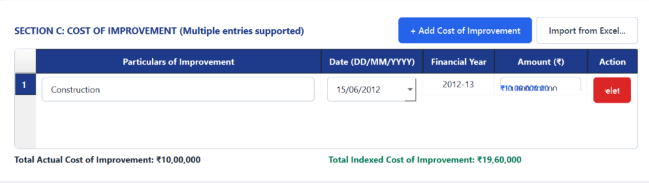
- Testing the working of the rectified “CGT Calculator” (.exe file) inside the “Dist” Folder autogenerated inside the CGT Calculator Folder created in the Step 1 as above.

As the final Results were found correct without any error/bug the AI tool is ready for Implementation.

PART – C: IMPLEMENTATION STAGE
- DASHBOARD
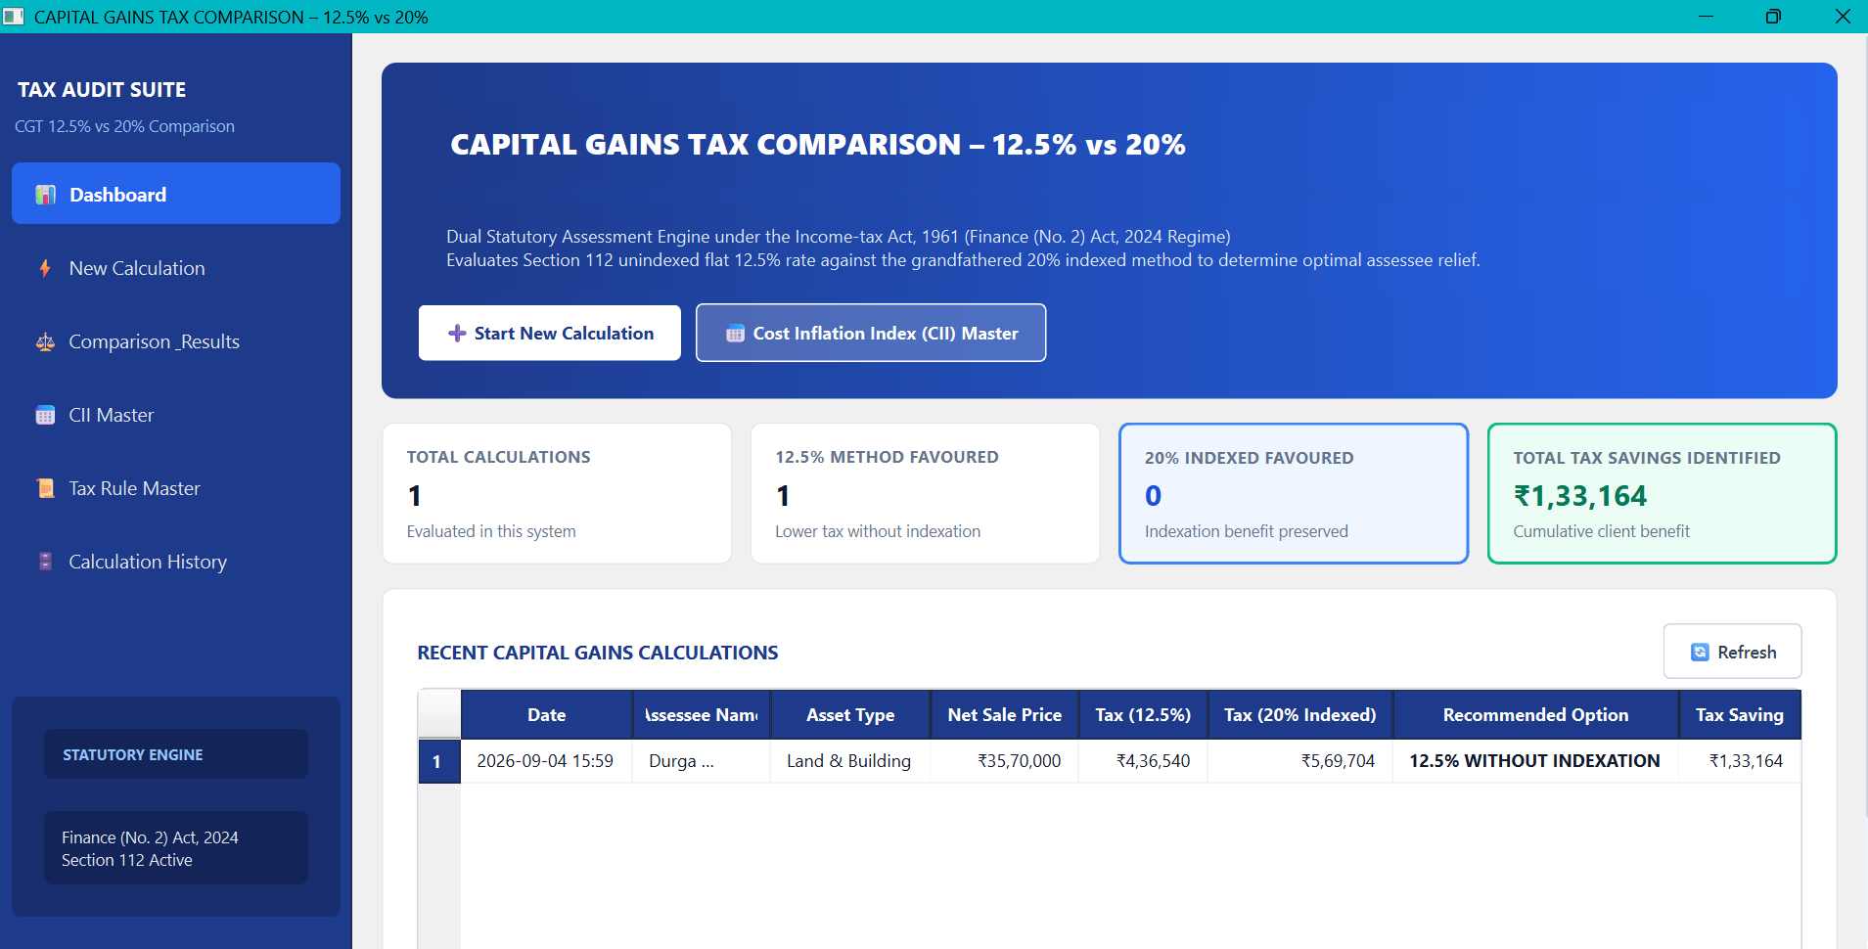

- NEW CALCULATION
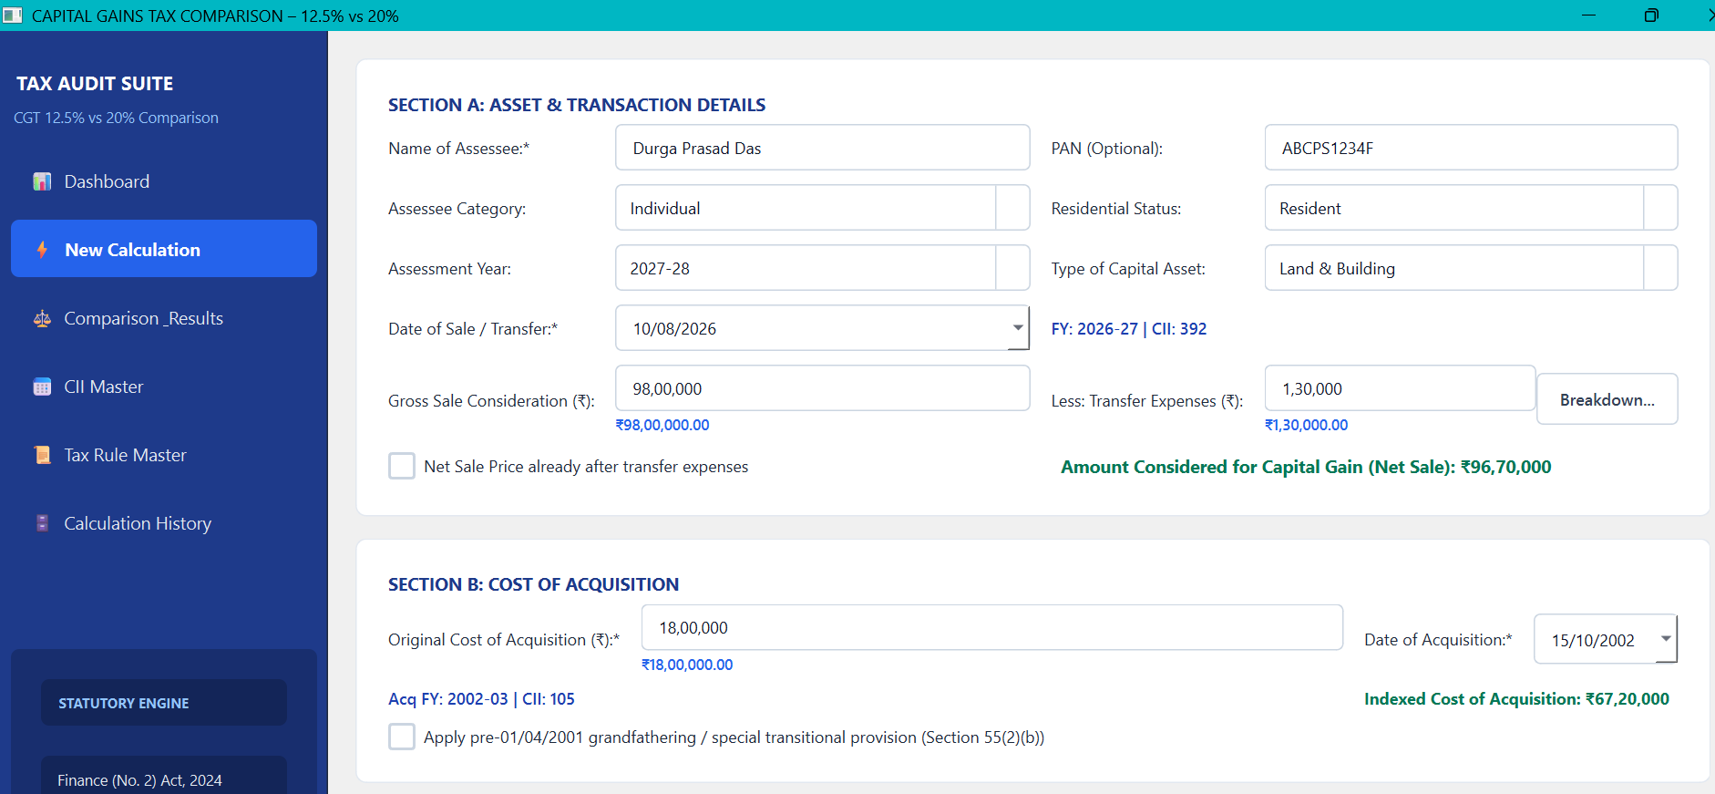

- COMPARISON RESULT
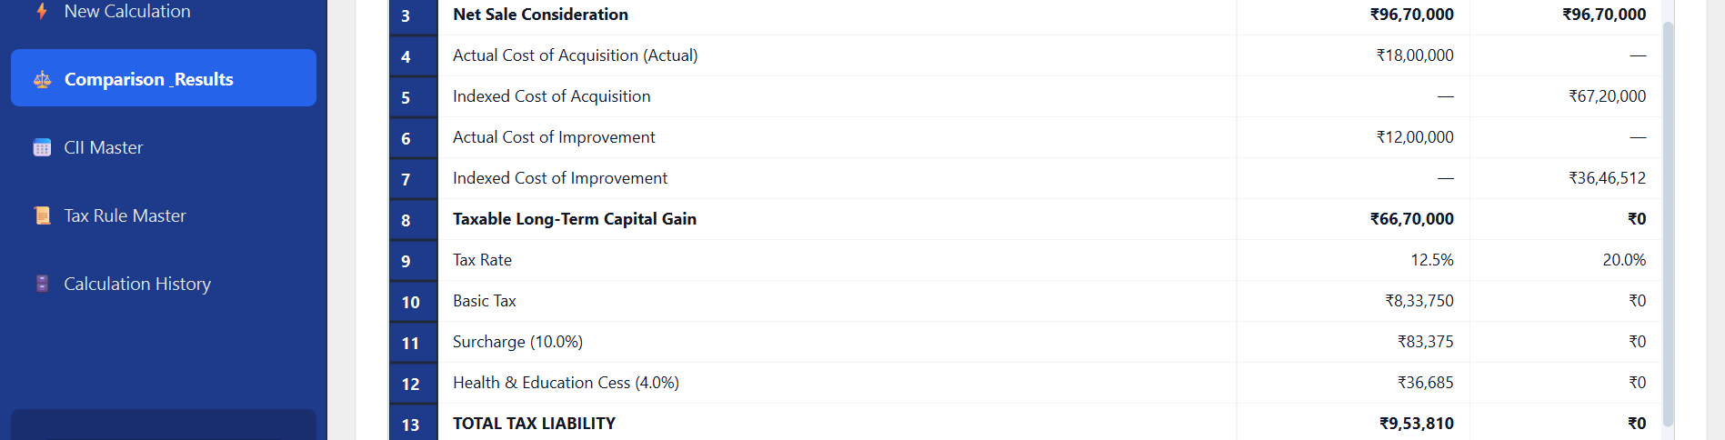
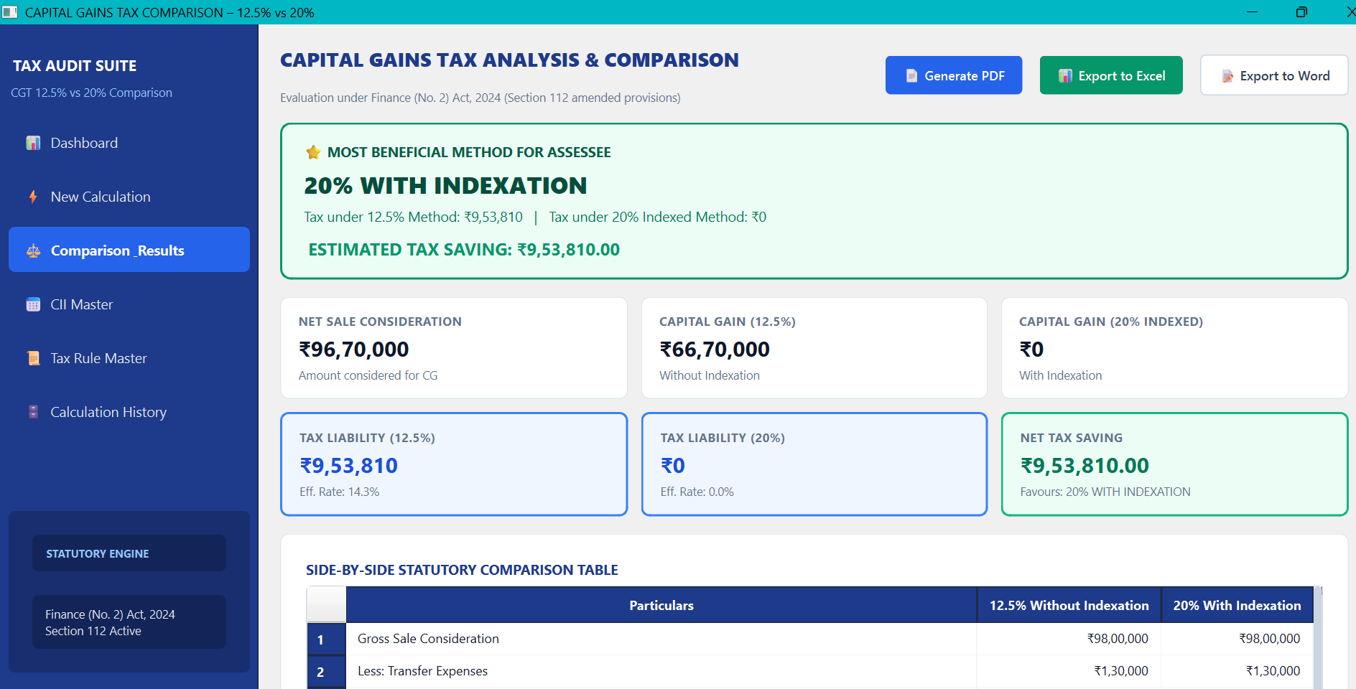

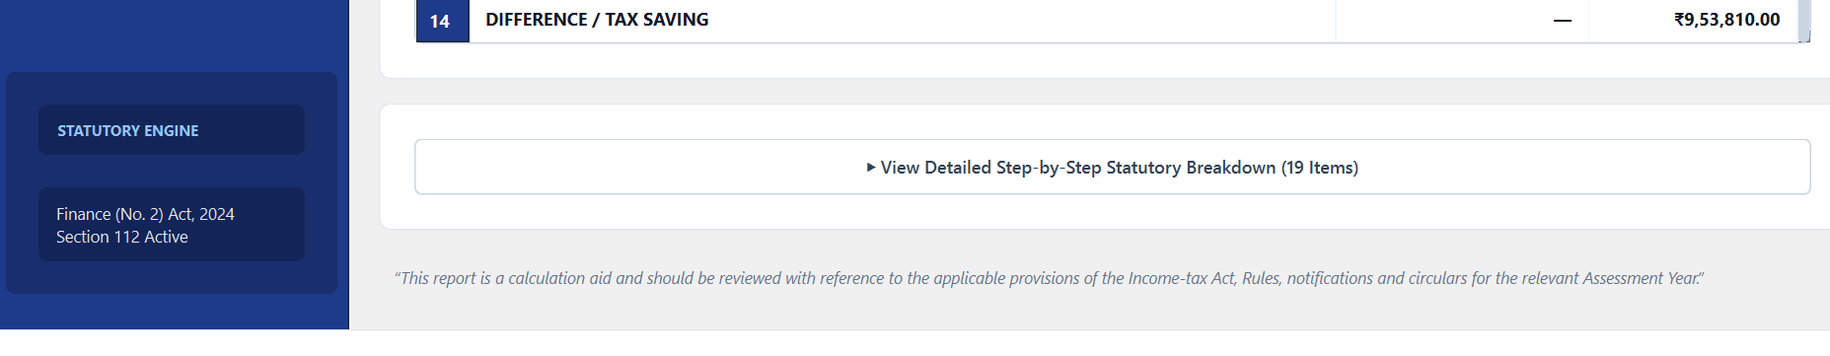

END OF PROJECT
Project Link:

Thank You
Rashmi Ranjan Mishra, FCA, DISA
M.No.: 218167

